# Question 1
# a. Describe the dataset using the one in package MASS.
library(MASS)

# b. Load the dataset and display its structure
data("crabs")

# c. Produce the frequency table for species and sex
[table(crabs$sp,crabs$sex)]
F M
B 50 50
O 50 50

# d. Construct an appropriate bar chart or mosaic plot summarising the group composition.

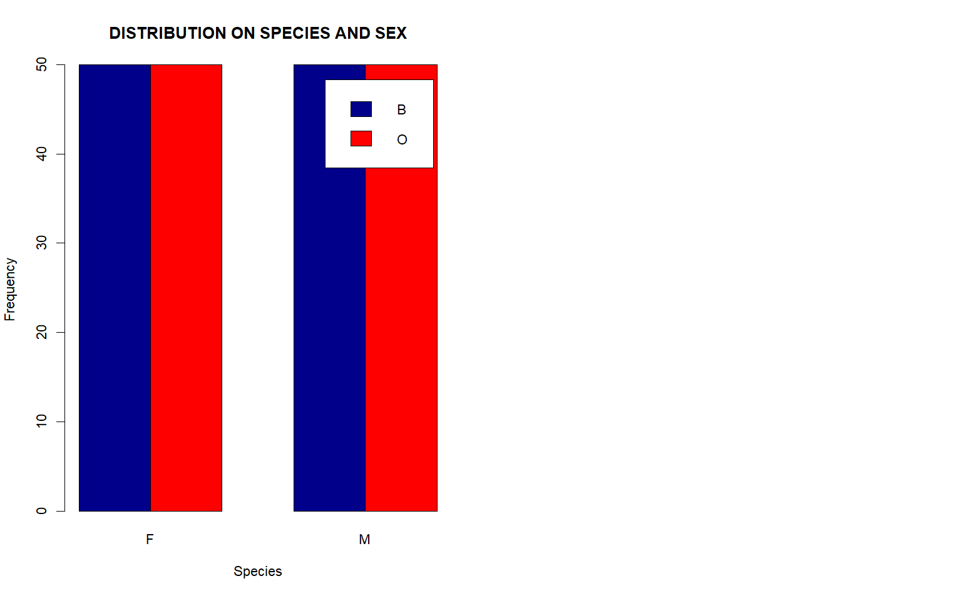ND SEX")

# e. Comment on whether the dataset is balanced across the four groups

# Yes — the dataset is balanced. There will be fair comparison between them.
# Equal numbers across both species and sex

# Question 2 - Distribution of Body Depth
# a. Construct side-by-side boxplots of body depth (BD) for the four groups defined by species and sex
group <- interaction(crabs$sp, crabs$sex)
boxplot(crabs$BD ~ group,
col = rainbow(4),
xlab = "SPECIES AND SEX",
ylab = "BODY DEPTH (BD)",
main = "BODY DEPTH (BD) BY SPECIES AND SEX")

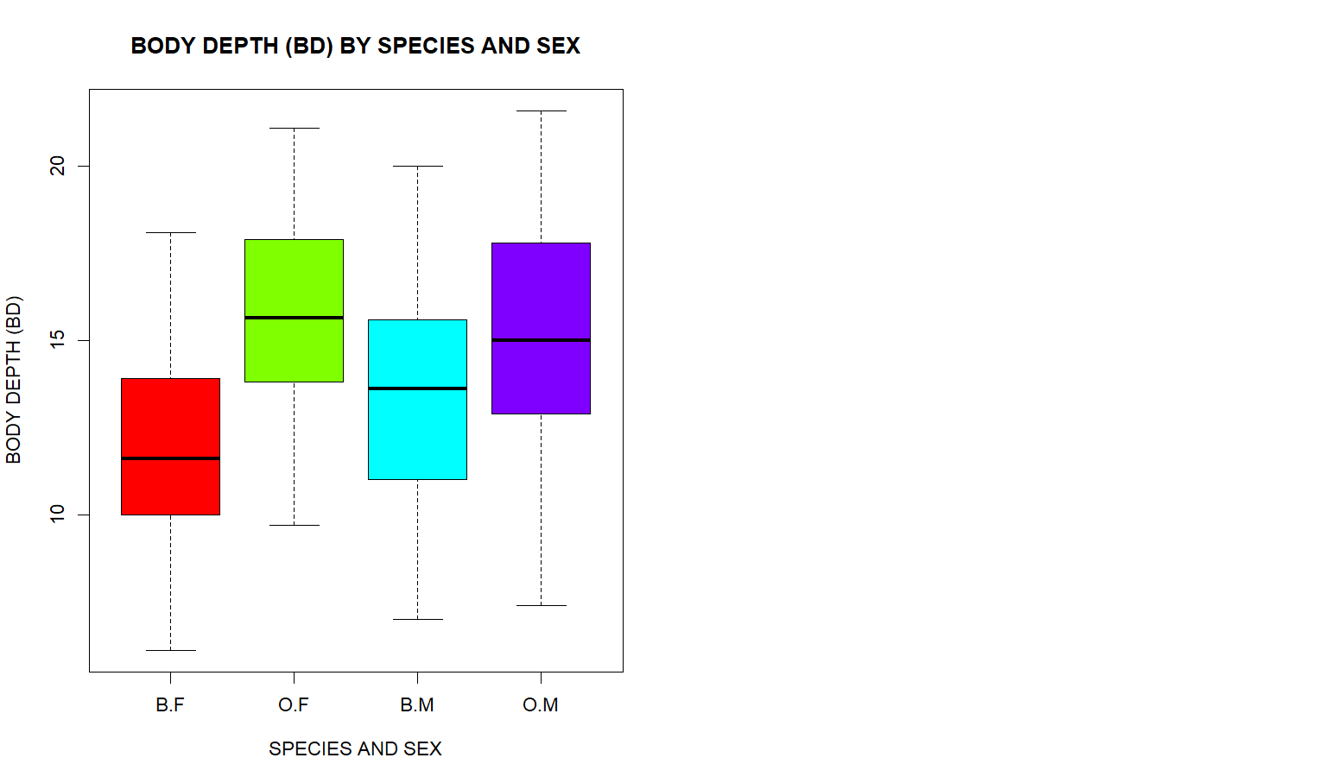

# b. Identify any outliers and compare the central tendency and variability between groups.

by(crabs$BD, group, boxplot.stats)

# From the boxplot analysis we can identify that there are no outliers in any of the groups.
# The central tendency of BD is similar across all groups.

# Question 3 - Carapace Length Distribution by Species
# a. Produce hsitograms of carapace length (CL) for each species
par(mfrow = c(1, 2))
hist(crabs$CL[crabs$sp == "B"],
col = rainbow(10),
main = "Carapace Length - Blue",
xlab = "Carapace Length (CL)",
breaks = 10)
hist(crabs$CL[crabs$sp == "O"],
col = rainbow(10),
main = "Carapace Length - Orange",
xlab = "Carapace Length (CL)",
breaks = 10)
par(mfrow = c(1,1))

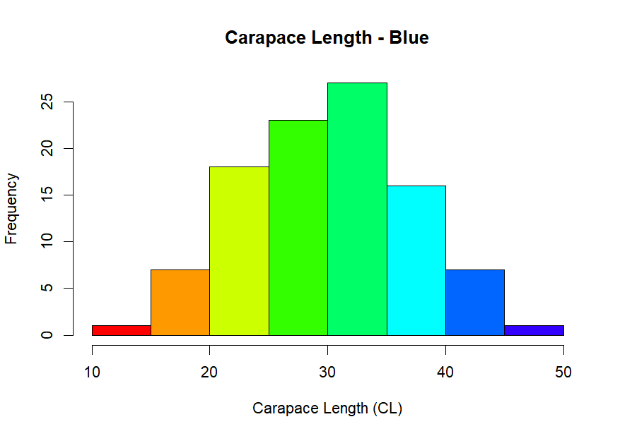

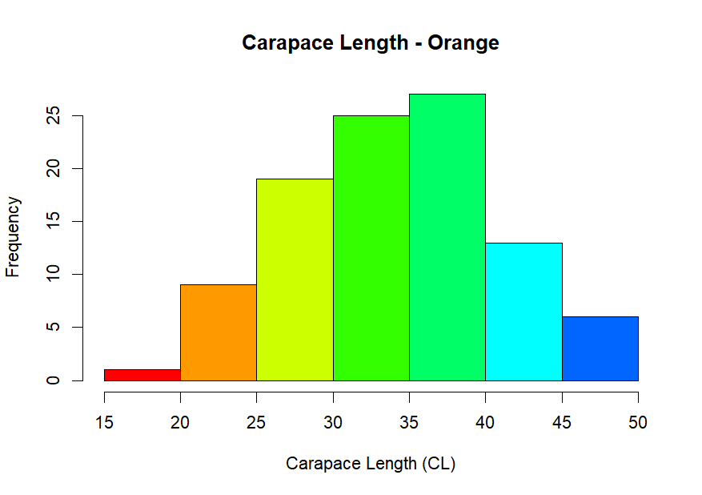

# b. Describe and compate the shapes of the distributions, commenting on skewness and modality

# - Shape and Modality
# We observe that both species (Blue and orange) have approximately bell shaped distributions
# Both distributions have a single clear peak with no evidence of multiple nodes

# - Skewness
#Both distributions are approximately symmetric.
# However, skewness not extreme.

# - Comparison Between Species

# From the diagrams, we can see that the orange crabs tend to have a slightly high
# caraplace length than the blue crabs, indicating a location shift between the two species.

# - Summary Interpretation
# Both species show roughly bell-shaped, unimodal distributions.
# There is no multimodality.
# The primary difference is a location shift, with Orange crabs generally larger than Blue crabs.

# Question 4. - Comparison of Mean Measurements
# a. Compute the mean of each morphological measurements (FL, RW, CL, CW, BD) by species and sex
means <- aggregate(cbind(FL, RW, CL, CW, BD) ~ sp + sex,
data = crabs,
FUN = mean)
means

# b. Construct a grouped bar chart to display these means

mean_of_measurements <- as.matrix(means[, 3:7])
rownames(mean_of_measurements) <- paste(means$sp, means$sex, sep = ".")
barplot(t(mean_of_measurements),
beside = TRUE,
col = c("violet","orange","lightgreen","grey"),
legend = rownames(mean_of_measurements),
xlab = "Morphological Measurement",
ylab = "Mean Value",
main = "Mean Morphological Measurements by Species and Sex")

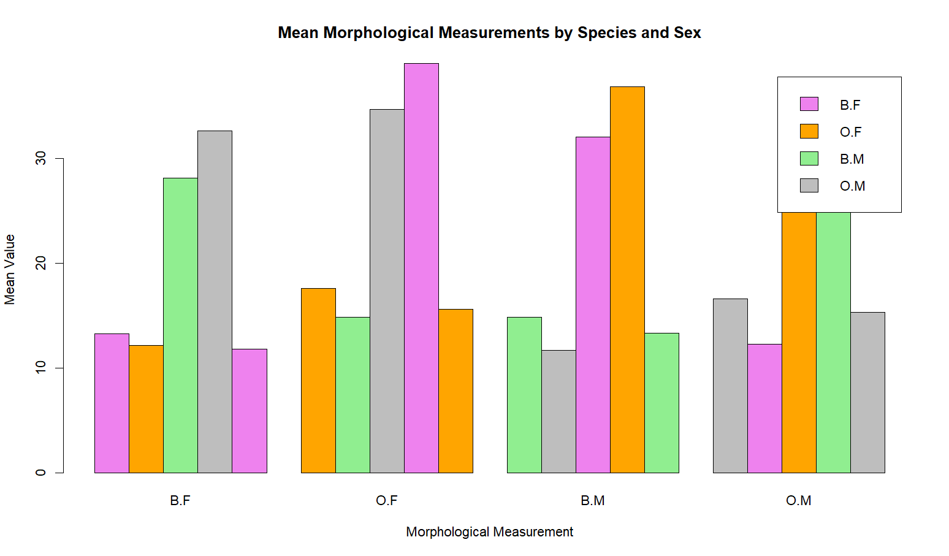

# c. Identify which measurement shows the greatest species difference and which shows the least sex variation.
# Species means (averaged over sex)

mean_of_measurements <- crabs %>%
group_by(sp) %>%
summarise(across(c(FL, RW, CL, CW, BD), mean))
species_diff <- abs(mean_of_measurements[1,2:6] - mean_of_measurements[2,2:6])
species_diff

# Sex means (averaged over species)
sex_means <- crabs %>%
group_by(sex) %>%
summarise(across(c(FL, RW, CL, CW, BD), mean))
sex_diff <- abs(sex_means[1,2:6] - sex_means[2,2:6])
sex_diff

# Question 5
# a
. Produce a scatterplot matrix (pair plot) of five measurements
pairs(crabs[, c("FL", "RW", "CL", "CW", "BD")],
main = "Scatterplot Matrix of Crab Measurements",
col = as.numeric(interaction(crabs$sp, crabs$sex)))
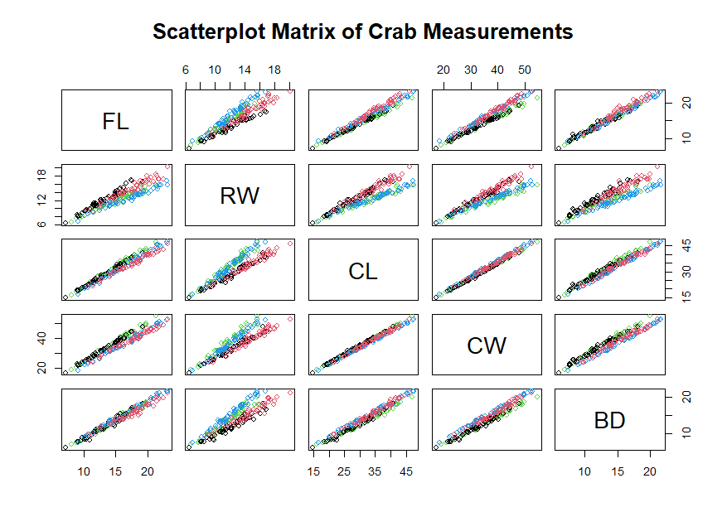

# b. Describe the strength and nature of the relationships among variables
# - Strength of Relationships
# All five measurements are strongly positively correlated.
# Larger crabs are large in all dimensions.
# This shows strong overall body size dependence.

# Relationships appear approximately linear.
# No obvious nonlinear patterns.
# No clear clustering beyond group differences.

# The strongest relationships are typically between:
# Carapace Length (CL) and Carapace Width (CW)
# Rear Width (RW) and Carapace Width (CW).

# The variables largely measure overall body size which also explains the strong
#positive correlations. The measurements are not independent of each other

### Question 6.

# The dataset consists of morphological measurements on 200 crabs of the species Leptograpsus variegatus. The sample is structured according to two categorical factors:
# Species (sp): Blue (B) and Orange (O) forms

# Sex: Male (M) and Female (F)

# This yields four equally sized groups: Blue Female, Blue Male, Orange Female, and Orange Male, with 50 observations each.
# Five continuous morphological measurements were analysed:
# FL – Frontal lobe size ,RW – Rear width,CL – Carapace length,CW – Carapace width and BD – Body depth.

# 2. Group Composition
# A frequency table and corresponding bar chart confirmed that the dataset is perfectly balanced: each species–sex combination contains exactly 50 crabs. This balance ensures fair visual and numerical comparisons across groups.

# 3. Distribution of Body Depth by Species and Sex
# Side-by-side boxplots of body depth (BD) revealed clear differences among the four groups.
# Males consistently exhibited larger median body depth than females within both species, indicating a strong sex effect. Orange crabs tended to have slightly larger medians than Blue crabs, suggesting a moderate species effect.
# Variability was broadly similar across groups, though male groups displayed slightly greater spread. Overall, body depth differences appear systematic rather than driven by extreme observations.

# 4. Distribution of Carapace Length by Species
# Histograms of carapace length (CL) for Blue and Orange crabs showed approximately unimodal, roughly symmetric distributions for both species. The shapes were close to bell-shaped with no evidence of multimodality.
# The primary difference between species was a shift in location: the Orange distribution was positioned slightly to the right, indicating generally larger carapace lengths. Variability appeared similar across species. Skewness, if present, was mild and slightly positive.
# This shows, differences between species are largely differences in overall size rather than distributional shape.

# 5. Mean Morphological Differences
# Group means for all five measurements were computed by species and sex and displayed using grouped bar charts.

# Two consistent patterns emerged:

# Sex Effect:
# Males had larger mean values than females across all five measurements. This suggests sexual dimorphism in overall body size.

# Species Effect:
# Orange crabs generally exhibited larger measurements than Blue crabs, although this difference was smaller than the sex effect.

# When comparing magnitudes of differences:
# Carapace Width (CW) showed the greatest difference between species, making it the measurement that most strongly distinguishes Blue and Orange forms.
# Frontal Lobe (FL) showed the smallest difference between males and females, indicating the least sex-related variation.

# Overall, measurements related to overall shell size (CL and CW) appear most sensitive to species differences, while FL shows relatively weaker differentiation by sex.

# 6. Relationships Among Morphological Measurements
# A scatterplot matrix (pair plot) of FL, RW, CL, CW, and BD revealed very strong positive linear relationships among all five variables.
# Key observations:
# All pairwise relationships were approximately linear.
# Correlations were very high (typically above 0.9).
# No clear nonlinear patterns were evident.

# Points formed elongated clouds consistent with a strong common size factor.
# The strongest associations were observed between:
# Carapace Length (CL) and Carapace Width (CW)

# Rear Width (RW) and Carapace Width (CW)
# These findings indicate substantial multicollinearity among variables. The measurements largely capture a single underlying dimension—overall body size. Differences between groups therefore primarily reflect differences in general size rather than shape.

# 7. Overall Interpretation
# The analysis presents a coherent picture of morphological variation in the crab sample:
# The design is perfectly balanced across species and sex.

# Males are consistently larger than females across all measurements.
# Species differences exist, with Orange crabs generally larger than Blue crabs.
# Carapace width most strongly differentiates species, while frontal lobe size shows the least sex variation.
# All five morphological measurements are highly correlated and shows a dominant underlying size component.
# This data indicate that variation in this crab population is driven primarily by overall body size, with clear and systematic differences attributable to both species and sex.

